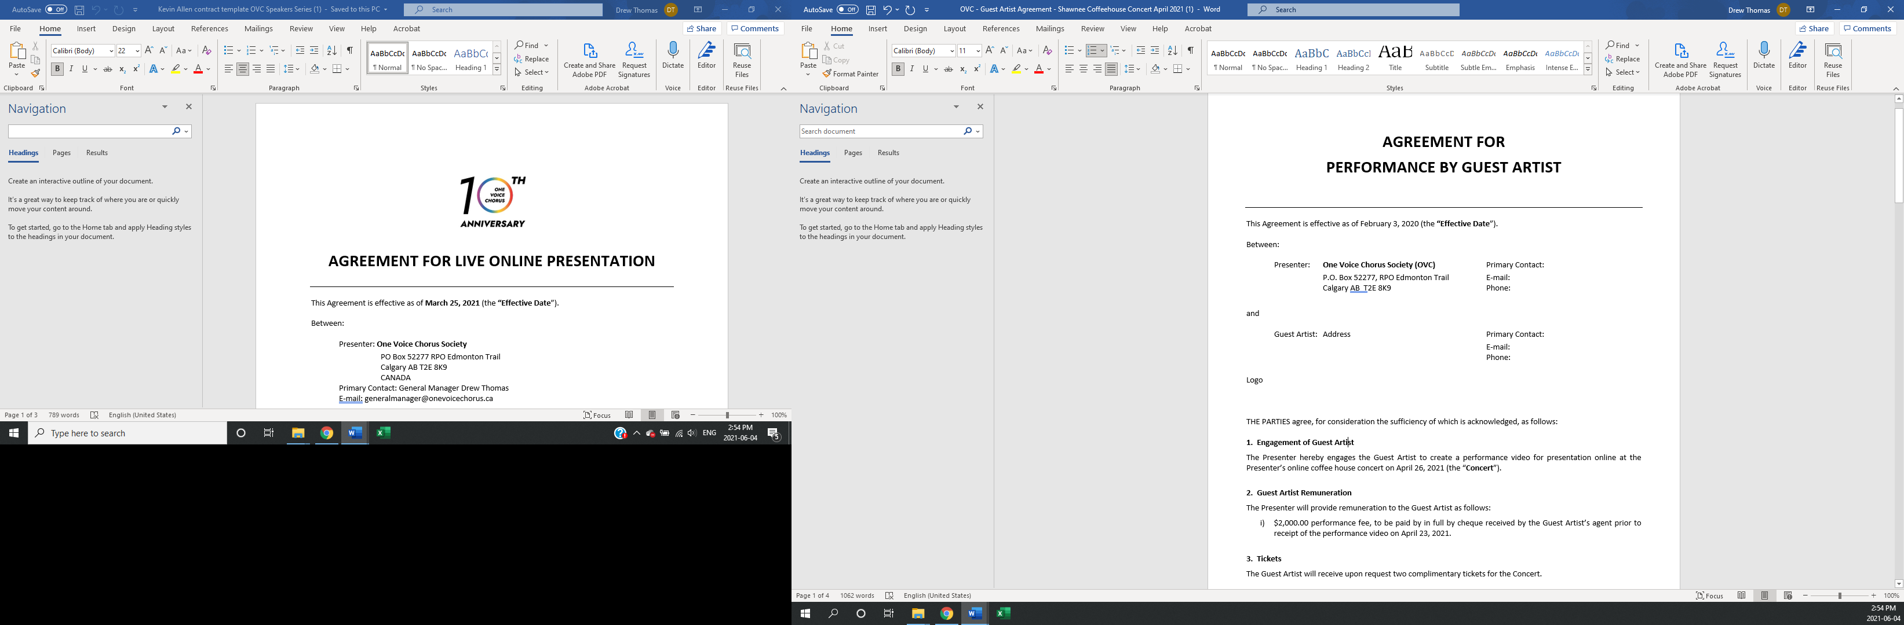
AGREEMENT FOR
PERFORMANCE BY GUEST ARTIST

This Agreement is effective as of Date (the “Effective Date”).

Between:

Presenter: Entity Primary Contact:
Address E-mail:
Phone:

and

Guest Artist: Entity Primary Contact:
Address E-mail:
Phone:

THE PARTIES agree, for consideration the sufficiency of which is acknowledged, as follows:

- Engagement of Guest Artist
- The Presenter hereby engages the Guest Artist to perform at the Presenter’s Blank concert on Date at location (the “Concert”).

- In addition to performing at the Concert, the Guest Artist will attend and participate in the Presenter’s dress rehearsal for the Concert on the evening of Blank at the Concert venue (the “Dress Rehearsal”).

- Guest Artist Remuneration
The Presenter will provide remuneration to the Guest Artist as follows:
- $Blank performance fee, to be paid the date of the Concert;

- The cost of the Guest Artist’s reasonable expenses for air travel from Blank to Blank and for accommodation in Blank for Blank, together not to exceed $Blank (the “Air Travel Expense” and the “Accommodation Expense” respectively, and together the “Expenses”). The Presenter will pay for the Accommodation Expense in advance, such payment to be provided directly to the accommodation provider agreed upon by the parties. The Presenter will reimburse the Guest Artist for the Air Travel Expense as such expense is incurred by the Guest Artist, upon provision to the Presenter of appropriate receipts; and

- A per diem in the amount of $Blank per day for two days, being the evening of Blank to the afternoon of Blank inclusively (the “Per Diem”), to be paid no later than the date of the Concert.

- Tickets
The Guest Artist will receive upon request two complimentary tickets for the Concert.

- Duties of the Guest Artist
- The Guest Artist will arrive at the Dress Rehearsal and the Concert at such times specified between the parties and will be fit to participate or perform in such activities, as applicable. The Guest Artist will abide by all reasonable rules and requirements the Presenter may establish in respect of the execution of the Dress Rehearsal and the Concert.

- Unless otherwise negotiated with the Presenter, the Guest Artist will provide musical services exclusively to the Presenter during the weekend of Blank and will not accept any other performance engagements during this time period with the exception of previously agreed upon performances on Blank at Blank and the Blank fundraiser.

- Promotion and Publicity
The Presenter is solely responsible for promotion and publicity for the Concert. The Guest Artist grants to the Presenter the right to make use of the Guest Artist’s name, photographs and other likenesses for the purposes of advertising, publicizing and promoting the Concert, and in historical reference to the Concert having taken place for the purposes of advertising, publicizing and promoting the Presenter. The Guest Artist confirms that all such uses of the Guest Artist’s name, photographs and other likenesses prior to the Effective Date were made with the Guest Artist’s express consent.

- Recording
Where the Guest Artist’s performance at the Concert is recorded, in whole or in part, the Guest Artist hereby releases the Presenter to use such recording(s) for its archives only. The Presenter will obtain an additional release from the Guest Artist prior to any other use of such recording(s).

- Insurance and Indemnity
- Unless otherwise agreed with the Presenter in writing, the Guest Artist is responsible for the acquisition of liability insurance coverage applicable to the provision of the Guest Artist’s services hereunder and for payment of the same.

- The Guest Artist will indemnify and save harmless the Presenter and its contractors, directors and members from all claims, damages, losses, costs and expenses including, but not limited to, in respect of personal injury, property damage or economic loss, which may arise as a result of the Guest Artist’s breach of any provision of this Agreement or any act of gross negligence by the Guest Artist.

- Termination
Either party may terminate this Agreement on 21 days’ written notice to the other party. In the event of termination by the Presenter, the Presenter will pay only the Expenses incurred by the Guest Artist to the date of termination and will have no further liability to the Guest Artist. In the event of termination by the Guest Artist, the Guest Artist will refund to the Presenter all remuneration paid by the Presenter to the date of termination, inclusive of the Expenses and the Per Diem, as applicable.

- Force Majeure
This Agreement will be null and void and neither of the parties will have any claim against the other for any loss, damage, expense or otherwise in the event of: i) sickness or injury of the Guest Artist, confirmed by a note from a medical doctor; ii) the performance being rendered impossible due to any legislative act of a public authority, civil tumult, strike or lock-out, epidemic, flood, fire, snowstorm, fog or other natural disaster; or iii) breakdown of transportation.

- Contractor Relationship
The Presenter hereby engages the Guest Artist as a contractor, and there is no employment, agency or partnership relationship between the parties. Neither party may incur any debts or make any commitments on behalf of the other. The Guest Artist is solely responsible for all statutory filings and payments required by any public authority in connection with the Guest Artist’s remuneration under this Agreement including, but not limited to, income tax.

- Entire Agreement
This Agreement constitutes the entire agreement between the parties, and supersedes all prior agreements, representations and understandings of the parties, written or oral.

- Amendments
This Agreement may be amended only by written agreement of the parties.

- Agreement Binding
This Agreement is binding upon and will inure to the benefit of the heirs, executors, administrators, successors and assigns of the parties, as applicable.

- Assignment
Neither the Presenter nor the Guest Artist may assign this Agreement or any part of this Agreement to any third party without the prior written consent of the other.

- Waiver
Any waiver of a party’s rights under this Agreement must be in writing.

- Severability
If any clause of this Agreement is held to be unenforceable by a court of competent jurisdiction, the remaining clauses will continue to apply.

- Notices
All notices provided for in this Agreement must be delivered personally or sent by registered mail to the mailing addresses specified in this Agreement. Either party may by like notice specify a change of address.

- Governing Law and Jurisdiction
This Agreement is governed by the laws of the Province of Alberta. The parties agree to submit to the non-exclusive jurisdiction of the courts of the Province of Alberta to resolve any disputes arising in respect of this Agreement.

- Survival
Those clauses of this Agreement which by their nature are intended to survive termination or expiry of this Agreement, will so survive.

- Counterparts and Delivery
This Agreement may be executed in counterparts and delivered by electronic means.

IN WITNESS WHEREOF, the Presenter and the Guest Artist have each executed and delivered this Agreement as of the Effective Date.

Blank , President Blank Guest Artist
Per: Entity

Blank , Treasurer Blank
Per: Entity

