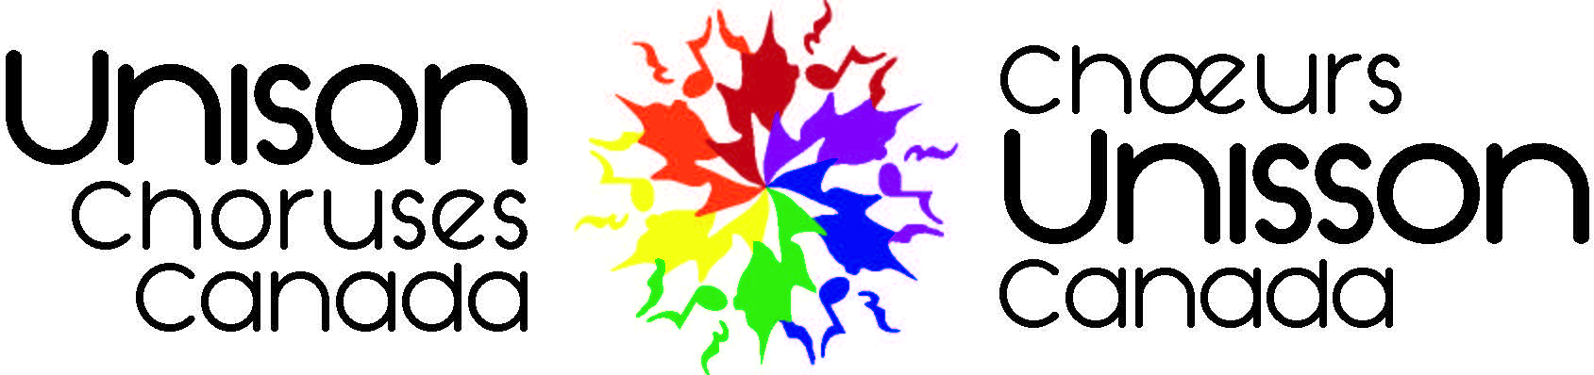

[date], 2021

[name]

Unison Choruses Canada

Dear [name],

We are pleased to present this sponsorship package and invite you to join us as a **[sponsorship level] Sponsor** of the **Unison Festival 2022 Halifax**. From June 30 – July 3, our events and programming will provide your business with access to our members and the general public to demonstrate a strong return on investment and help you build upon your community investment strategy.

[insert sentence from their community investment strategy and link it back to Unison]

The Unison Festival 2022 Halifax will welcome up to 600 delegates from 20 choirs and showcase artistic works from across the country for the enjoyment of the public and members of the 2SLGBTQIA+ community within the Halifax region.

**We hope you will follow our rainbow beacon into Halifax’s open harbour!** We have approached [business name], because of the alignment of your community investment strategy. Emerging out from the last year-and-a-half to look at new opportunities to come together with businesses like yours is a great way to showcase the resilience of the Halifax region and all of its inhabitants.

We are excited to meet with you to see if there is an opportunity for us to sit down, discuss our shared goals and explore this opportunity together to ensure we create a reciprocal and mutually beneficial partnership with Unison Choruses Canada, for [business name] and our audiences.

Thank you for your consideration of this important 2SLGBTQIA+ community festival and we look forward to connecting!

**[name]**

[title]

Unison Choruses Canada

Tel: 1-***-***-***

[email]

**unisonfestivalunisson.ca**